Flex Approval in Pega

So basically this is one component developed by Pega for Flexible Approval.

Standard Approval shapes are a fundamental part of any Pega Architect's toolkit, commonly employed when an approval step is necessitated in a process. However, business needs can often evolve beyond the standard capabilities of Approval shapes, necessitating a shift to an Assignment shape.

The Flexible Approval Component is designed to expand upon the standard Approval shape capabilities within Pega, providing Pega Architects with a more versatile and dynamic tool to meet complex business requirements.

So we can find this from Pega Marketplace.

<https://community.pega.com/marketplace/component/flex-approval#:~:text=The%20Flexible%20Approval%20Component%20is,to%20meet%20complex%20business%20requirements>.

Now we can download the zip file and import it into the Pega application

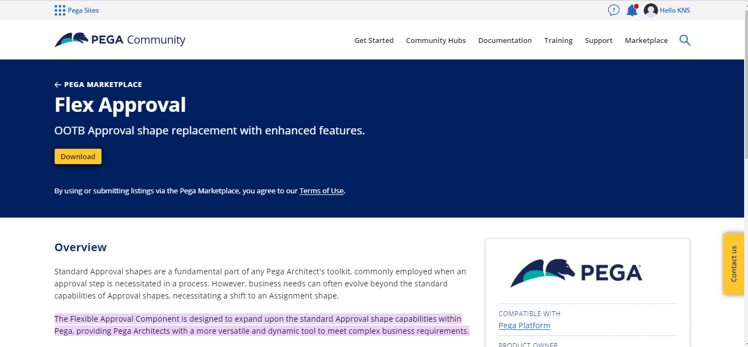

And login to the instance and import it

After importing add the component from the definition of the application.

Added the component and 2 rulesets get created

* FlexApproval
* FlexApprovalSamples

In the samples ruleset we have one navigation rule which we need to save into our application ruleset

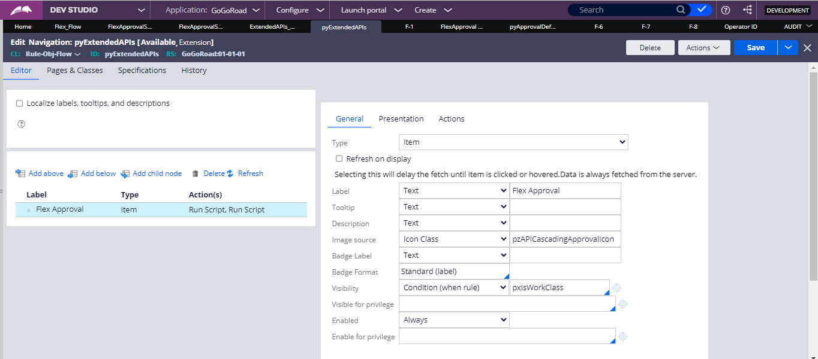

And now we can save the rule and then the shape will be shown in the flow as an automation shape and we can configure inside it

The options available inside it are

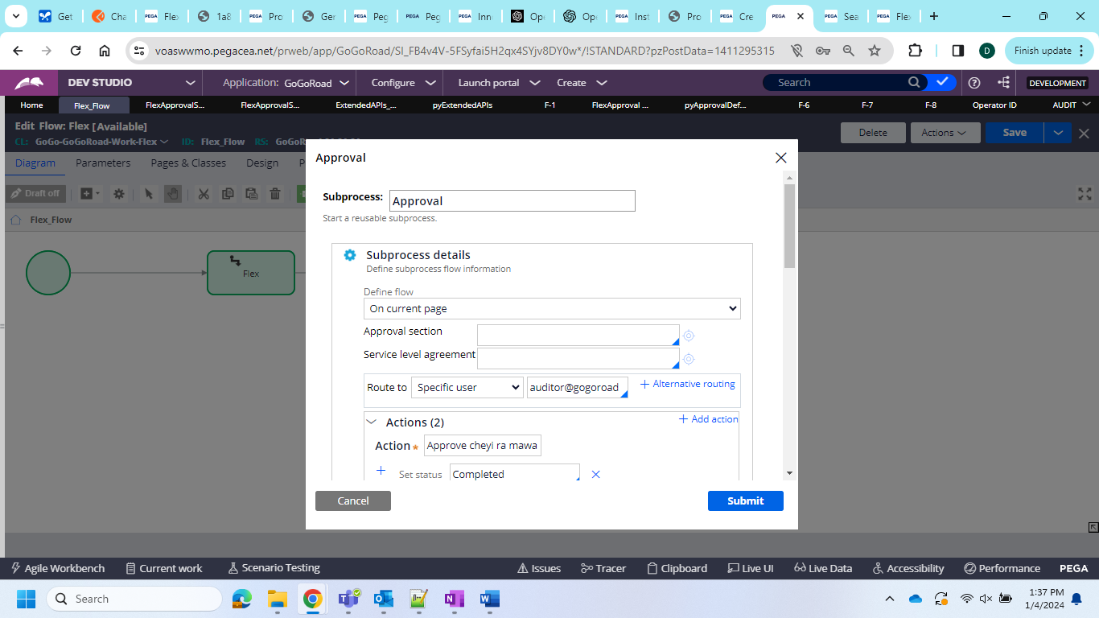

And it also allows to get the usage of the approval options would be increased in Pega.

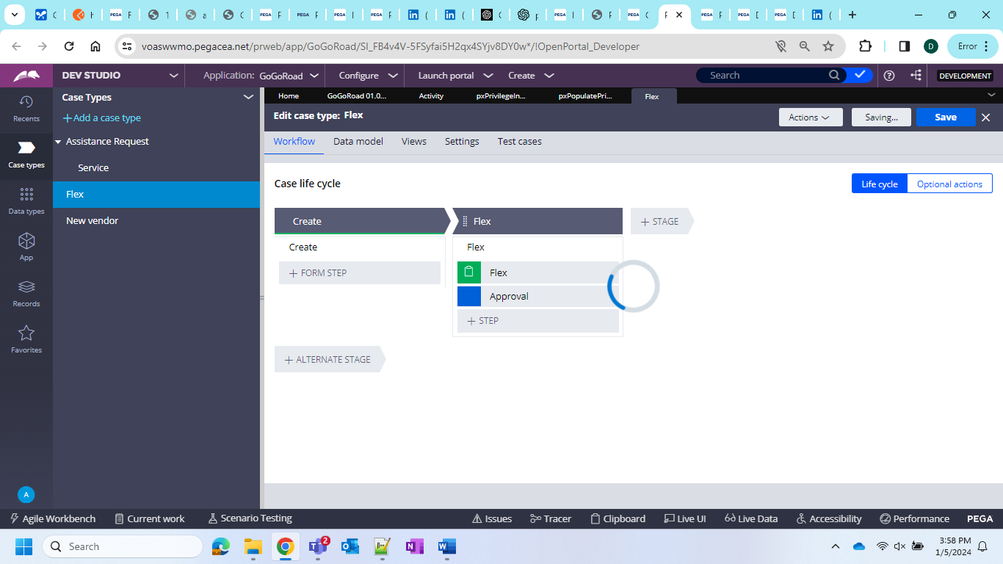

In case type included lets run and see all the functions

Upon reject mandatory validation

Upon approve mandatory validation

So its kind of approvals included in a smart shape